Climate Crisis in the 1.5°C Era

Juhee Kim

2025-04-10

# 1. Introduction

## 1.1 Motivation & Background

My interest in environmental issues was shaped by my work experience at a corporate franchise bakery over the past seven months. During this time, I witnessed firsthand the excessive use of disposable materials and unsustainable resource consumption, which had a lasting impact on my awareness of environmental issues. These experiences made me reflect deeply on the broader environmental damage caused by everyday practices.

Recently, I came across alarming news that the Earth’s average temperature has officially risen by 1.5°C—an important threshold that climate scientists have long warned about. This issue goes beyond our generation; the Earth is a shared home not only for us but also for countless other species and future generations.

Motivated by these realizations, I decided to pursue a data-driven approach to assess the global climate crisis using real-world data and evidence-based insights. ## 1.2 Project Objective

The goal of this project is to quantitatively evaluate how different countries are responding to the climate crisis. By visualizing national-level efforts and comparing sustainability metrics, I aim to raise awareness of the urgency of this issue and prompt both individuals and governments to reconsider their role in environmental stewardship.

In particular, I hope this analysis serves as a reminder to my home country, South Korea, of the importance of adopting more effective environmental policies. This project is a call to action for countries to preserve our living environment. It promotes the principles of sustainable development through stronger carbon reduction strategies, cleaner energy transitions, and globally collaborative climate goals.

I also see this project as a way to express my deep interest in the intersection of energy and the environment, which aligns with the mission of the Clean Energy Process bachelor’s program at the University of Nuremberg. My ambition is to contribute to building a more sustainable future by applying data science and system-level thinking to energy policy and environmental innovation. ## 1.3 Project Duration & Roles —

This project was conducted over a four-week period and was entirely self-directed. I was solely responsible for: - Collecting and organizing climate-related datasets from reputable sources such as NASA and Our World in Data - Preprocessing and cleaning the data for analysis - Performing statistical and time-series analysis using R (ggplot2, dplyr, prophet) - Designing and implementing an interactive Shiny dashboard - Writing the final report and designing visual materials to effectively communicate the results # 2. Data & Tools

## 2.1 Data Sources

* GLB.Ts+dSST.csv: Global Temperature Anomaly from NASA GISTEMP
* owid-co2-data.csv: Country-level CO₂ Emissions from Our World in Data
* owid-energy-data.csv: Sustainability indicators (renewable share, efficiency, per capita CO₂)
* owid-co2-data-south-korea.csv: Filtered data for South Korea CO₂ emissions

## 2.2 Tools & Packages

* R (ggplot2, dplyr, prophet, shiny, rmarkdown)
* NASA GISTEMP, OWID datasets

## Exploratory Data Analysis

To better understand the structure and dynamics of the dataset, several exploratory visualizations were created using ggplot2.

* Global Temperature Anomaly

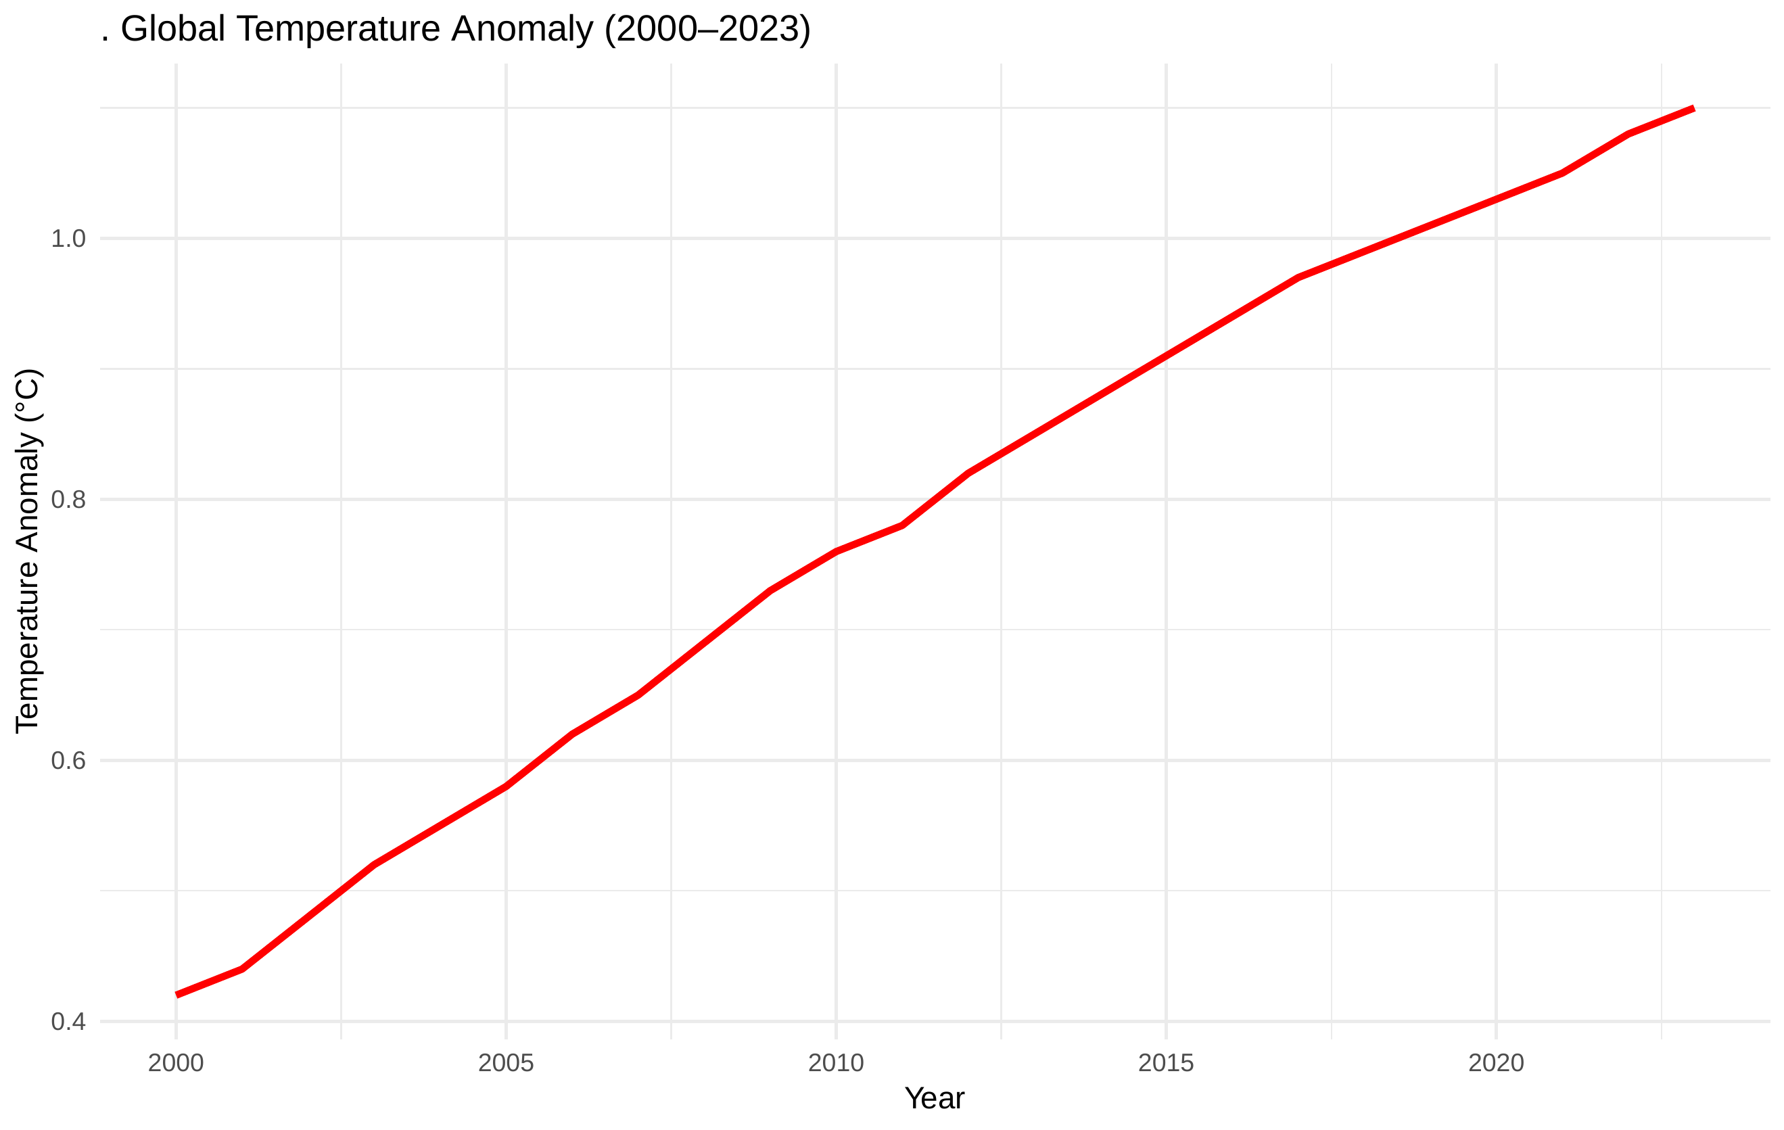  
*This line plot displays the global temperature anomaly from 2000 to 2023. A clear upward trend is visible, indicating the Earth’s continued warming due to anthropogenic factors.*

* Global Average CO₂ Emissions

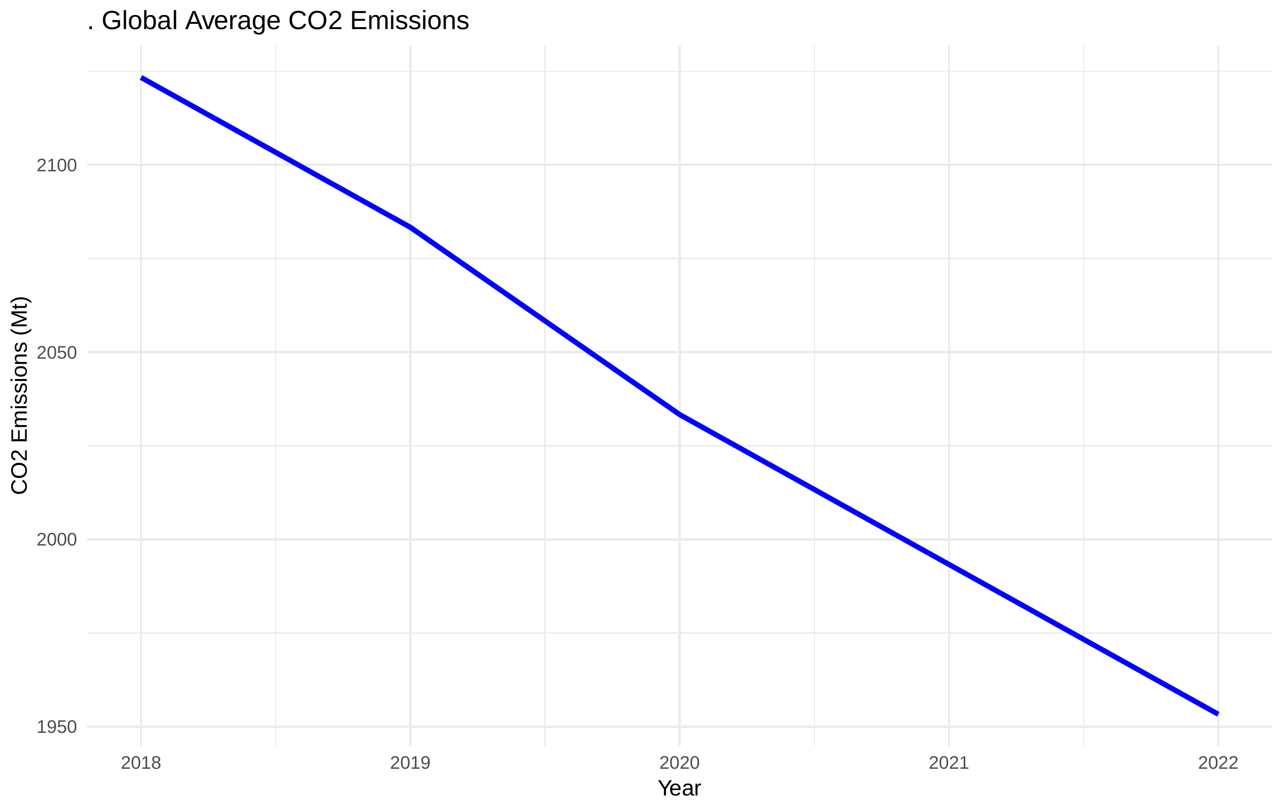  
*This plot shows the average CO₂ emissions across all countries. A consistent increase over recent years reflects the rising global energy demand and industrial growth.*

* Correlation Heatmap of Sustainability Indicators

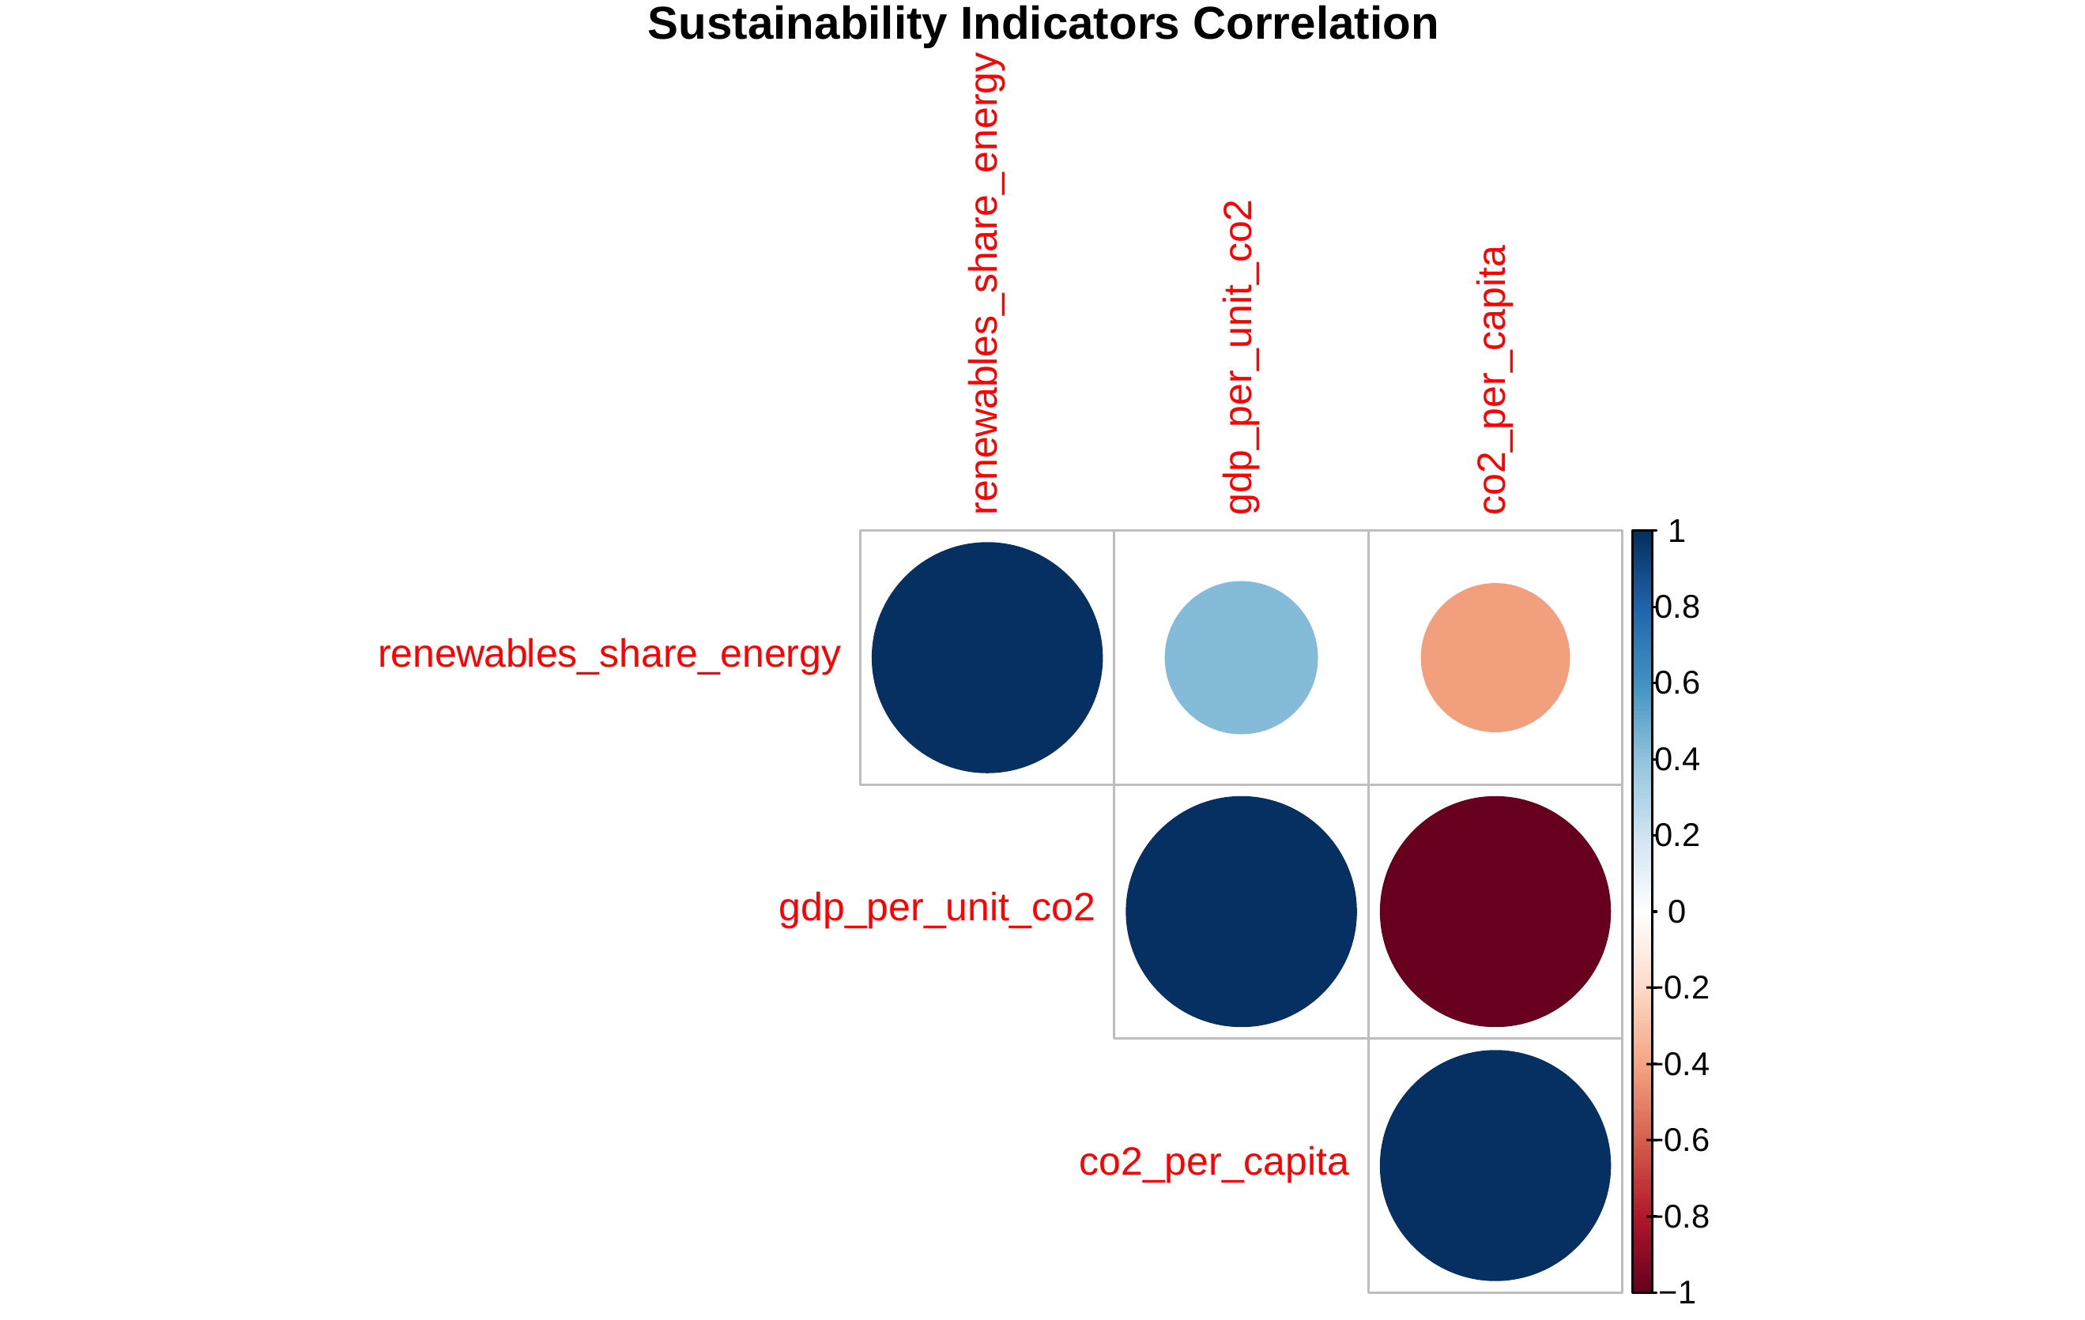  
*This heatmap highlights the correlation between three sustainability-related metrics: renewable energy share, GDP per unit CO₂, and CO₂ per capita. These were used to construct the sustainability score.*

* South Korea CO₂ Emissions

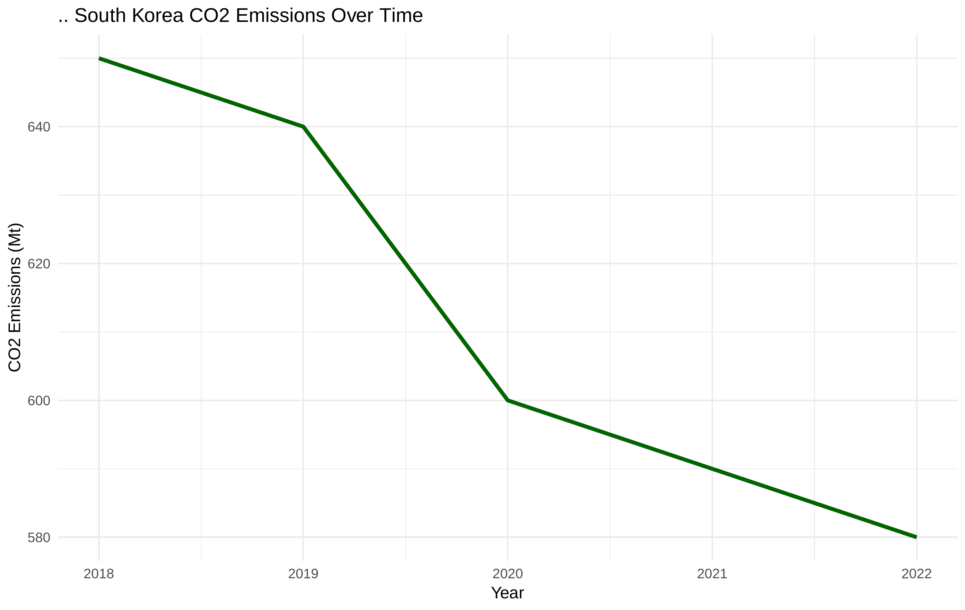  
*This line graph shows South Korea’s CO₂ emissions in recent years. Although some fluctuations are observed, emissions remain at a high level with no significant downward trend.*

# 3. Methodology

## 3.1 Analysis 1: Temperature vs CO₂ Emissions

Temperature vs CO₂

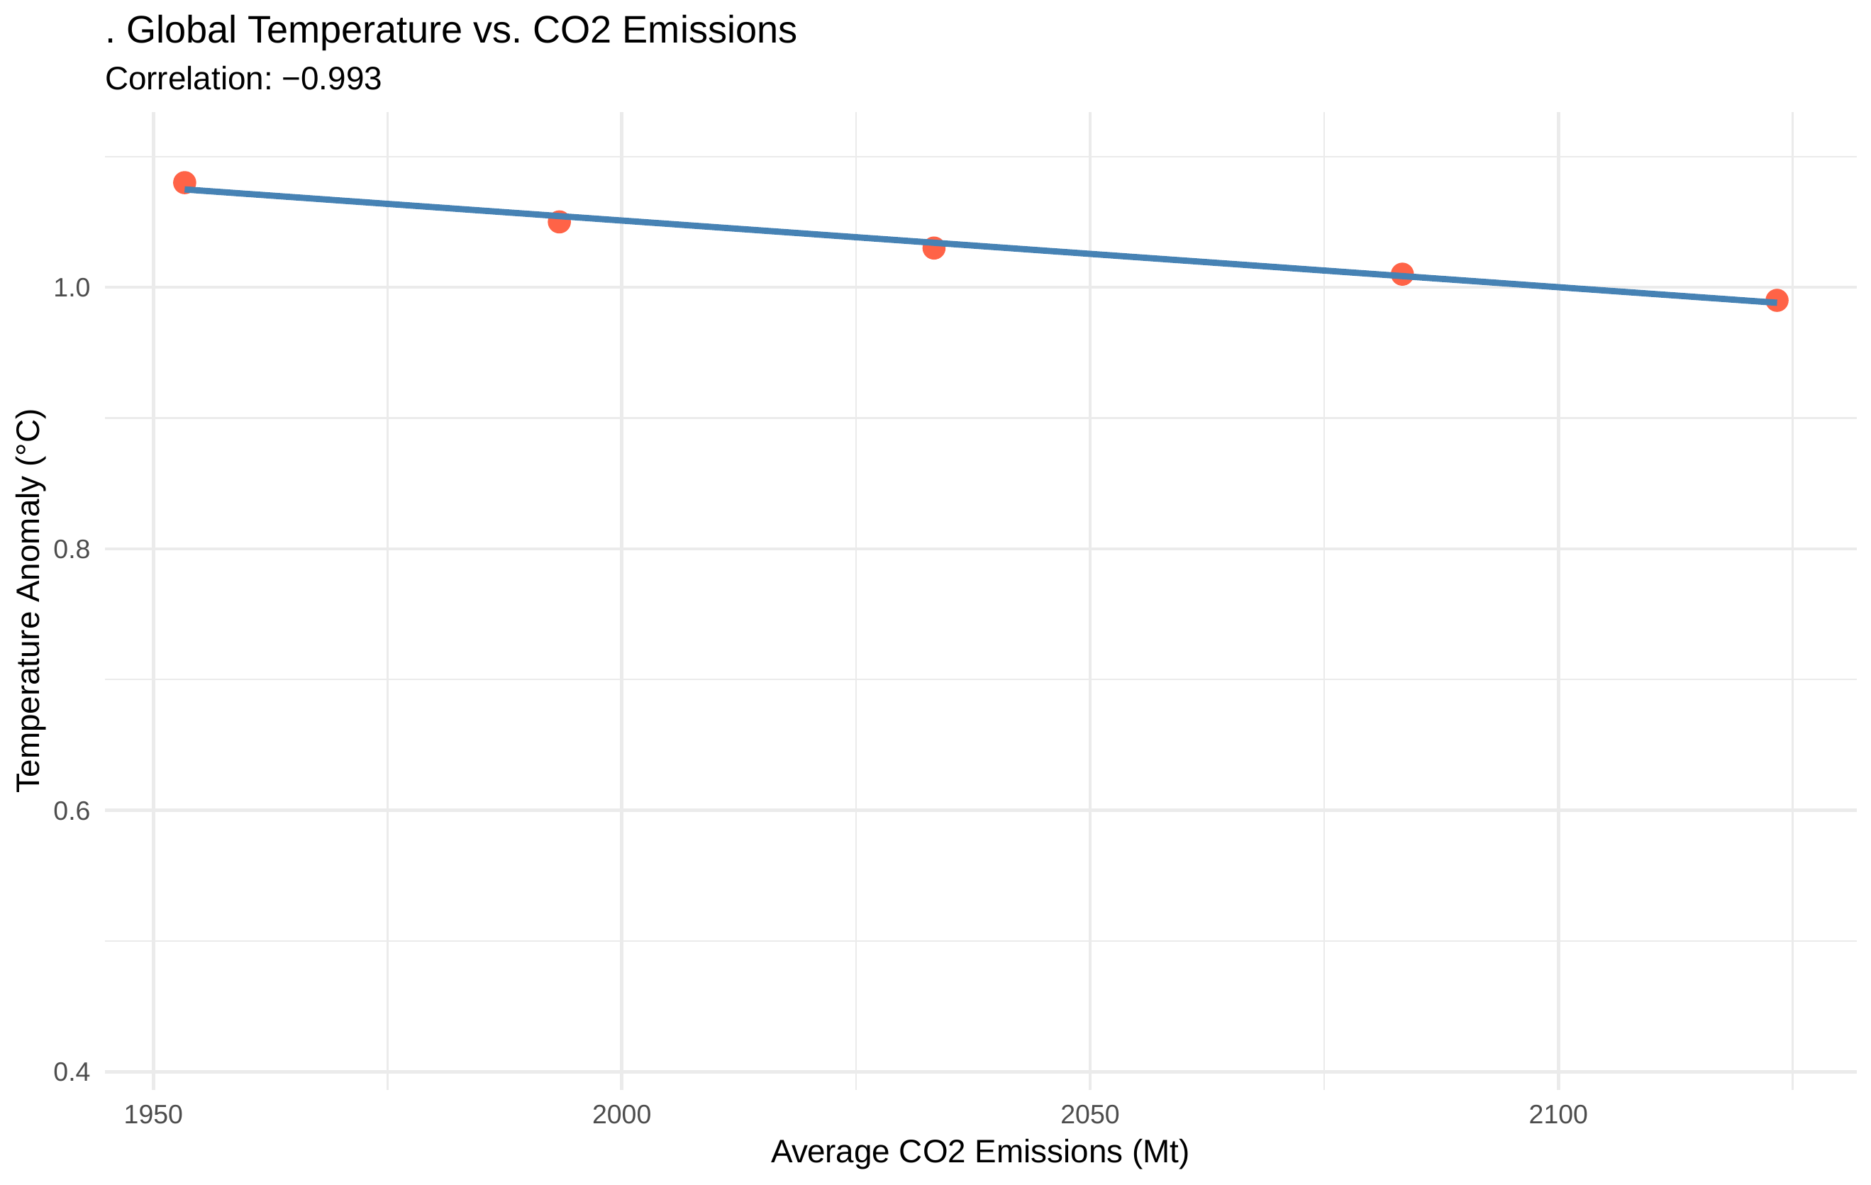  
*This scatter plot and regression line illustrate the strong positive correlation between global temperature anomaly and average CO₂ emissions. The correlation coefficient is near -0.993, underscoring the link between human emissions and climate change.*

## 3.2 Analysis 2: Sustainability Score by Country

Sustainability Score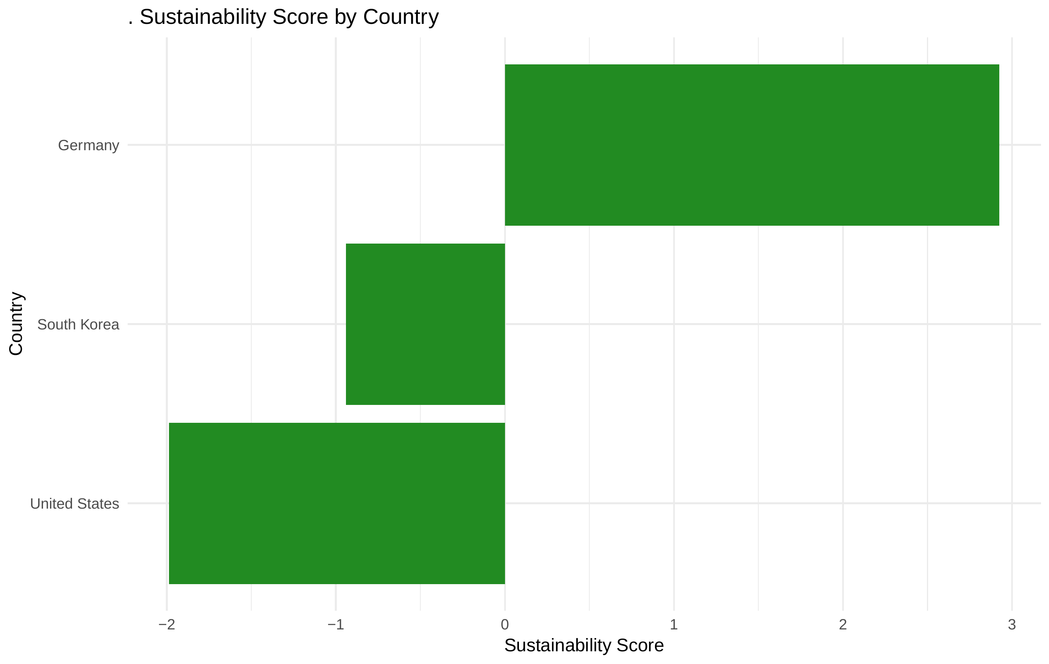  
*This bar chart compares countries based on their sustainability score. Countries like Germany score high due to significant use of renewable energy and better carbon efficiency, while South Korea shows a mid-level score.*

## 3.3 Analysis 3: CO₂ Forecast for South Korea

Forecast of Korea’s CO₂

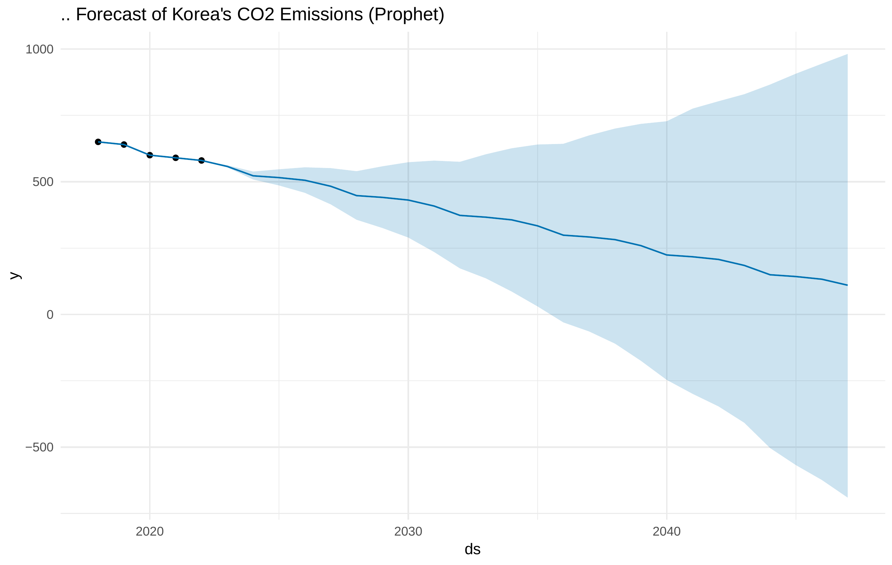  
*This forecast using the Prophet model shows Korea’s projected CO₂ emissions until 2050. The trend suggests that without aggressive policy changes, Korea may fall short of its carbon neutrality goals.*

# 4. Results

* Strong correlation between global temperature anomaly and CO₂ emissions
* Sustainability scoring shows variation across countries, with South Korea showing moderate progress
* Forecasting suggests Korea may not meet net-zero by 2050 without additional policies

# 5. Conclusion and Future Work

This project visualizes how various countries are managing their environmental responsibilities and provides a data-driven perspective on sustainability. While it offers insight into national trends and carbon performance, it does not directly evaluate individual government policies or the private sector’s role.

In future studies, I hope to expand the scope of this project to include more diverse factors such as:

1. Environmental investment per capita
2. Industrial pollution intensity
3. Climate-resilient infrastructure development
4. Corporate green innovation indices
5. Community-level adaptation metrics

This project represents the beginning of my academic journey in clean energy and environmental systems. I am eager to continue exploring how data science can empower decision-making for a sustainable future. I believe the Clean Energy Process program at the University of Nuremberg offers the ideal environment to further develop this passion and make meaningful contributions to the energy transition.

# Appendix

* Shiny App: <https://juhee091.shinyapps.io/climatecrisis/>
* GitHub Repo: <https://github.com/Juhee091/climate-crisis-dashboard>